Practical 11

Part A
1) | Save/load: make a small class Serializable, save an array of its objects to a file with ObjectOutputStream, then read it back into fresh objects and confirm the values survived. Mark one field transient and show it is not saved.
 | SaveDemo.java
Code | import java.io.*;  class Student implements Serializable {  private static final long serialVersionUID = 1L; String name;  int marks;  transient String password;  Student(String name, int marks, String password) {  this.name = name; this.marks = marks; this.password = password;  }  }  public class SaveDemo {  public static void main(String[] args) throws Exception {  Student[] students = {new Student("Tej",90,"abc"), new Student("Riya",85,"xyz")};  try (ObjectOutputStream out = new ObjectOutputStream(new FileOutputStream("students.dat")))  {  out.writeObject(students);  }  Student[] loaded;  try (ObjectInputStream in = new ObjectInputStream(new FileInputStream("students.dat"))) { loaded = (Student[]) in.readObject();  }  for (Student s : loaded) {  System.out.println(s.name + " " + s.marks + " Password: " + s.password);  }  System.out.println("Fresh object: " + (students[0] != loaded[0]));  }  }
Output | 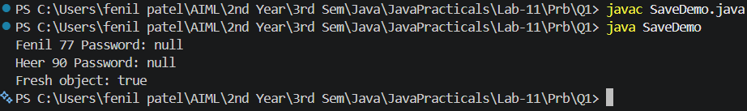

2) | Log analyzer: create a few text files, then use Path/Files to read each line by line and count the total lines and how many contain a keyword across all files; also print each file’s size from its attributes.
 | LogAnalyzer.java
Code | import java.nio.file.*;  import java.nio.file.attribute.BasicFileAttributes; import java.io.BufferedReader;  public class LogAnalyzer {  public static void main(String[] args) throws Exception {  Path folder = Path.of("samplelogs"); Files.createDirectories(folder); Files.writeString(folder.resolve("one.log"), "login OK\nlogin ERROR\n"); Files.writeString(folder.resolve("two.log"), "payment ERROR\n"); String keyword = "ERROR";  int lines = 0, matches = 0;

try (DirectoryStream<Path> files = Files.newDirectoryStream(folder, "*.log")) { for (Path file : files) {
BasicFileAttributes attr = Files.readAttributes(file, BasicFileAttributes.class); System.out.println(file + " Size: " + attr.size());
try (BufferedReader reader = Files.newBufferedReader(file)) { String line;
while ((line = reader.readLine()) != null) { lines++;
if (line.contains(keyword)) { matches++; }
}
}
}
}
System.out.println("Lines: " + lines + " Matches: " + matches);
}
}
Output | 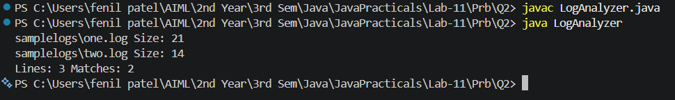

3) | (For Advanced Learners – home) Walk a folder tree with NIO and produce a report of the files it contains (name, size, modified time), writing the summary to a file; decide what to include.
 | TreeReport.java
Code | import java.nio.file.*;  import java.nio.file.attribute.BasicFileAttributes; import java.util.stream.Stream;  public class TreeReport {  public static void main(String[] args) throws Exception {  Path root = Path.of("sampletree"); Files.createDirectories(root.resolve("sub")); Files.writeString(root.resolve("sub/a.txt"), "Hello");  Path report = Path.of("tree-report.txt"); StringBuilder text = new StringBuilder();  try (Stream<Path> paths = Files.walk(root)) {  for (Path file : paths.filter(Files::isRegularFile).toList()) {  BasicFileAttributes a = Files.readAttributes(file, BasicFileAttributes.class); text.append(root.relativize(file)).append(" ").append(a.size())  .append(" ").append(a.lastModifiedTime()).append("\n");  }  }  Files.writeString(report, text); System.out.print(text);  }  }
Output

